Introduction to Computer Organization – Fall 2024

Lab 3
Due: @11:55 PM, Wed September 18th via Gradescope

The following assignment is intended to be completed during your assigned lab period. One member of your group must submit the assignment to Gradescope by the posted deadline and indicate your group members when submitting the assignment. Each group member must be present during the scheduled lab period in order to receive credit.

Group names and uniqnames

Group Member Name | Uniqname

For each of the following problems, one person should act as the "scribe" and log the discussions of the group. You should rotate who is the scribe for each problem and indicate in the given space.
Problem 1: Introduce Yourselves [2 points]

Scribe: [Scribe's name here]

This is the group of students you will be working with for the next few weeks. You will meet once a week to work through problems related to the class, but many students use these groups to form extra study groups to discuss projects, exams, etc.

Take a few minutes to go around the group and introduce yourselves.

Pod Member Name | Year | What's something you are looking forward to this semester?

Problem 2: GodBolt [24 Points]

Scribe: [Scribe's name here]

Go to godbolt.org. This is a website that will compile source code from several different programming languages into one of many target assembly languages, and color code the correspondence between the two programs.

In the left hand window, select "C" is the source language and paste in the following code:

#include <stdlib.h>
void scale_array(unsigned long long *arr, unsigned long size) {
int i=0;
while(i<size) {
unsigned long long temp = arr[i];
temp *= 100;
arr[i] = temp;
i++;
}
}

Your window should look like this (with perhaps rows highlighted as different colors)
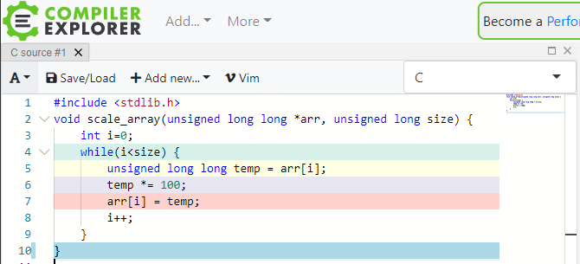

In the right hand window,select "carm64g820” or “ARM64 gcc 8.2" for the architecture and "-O2" for the compiler options:

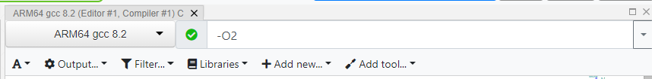

After a moment, the right window should be populated with ARM assembly code. You can see which C statements each instruction corresponds to by matching the colors between the two windows.

Because this compiler is using the full Arm assembly language (not just the LEG subset described in lecture), there are a few instruction variants you may be unfamiliar with (note that we do NOT expect you to be familiar with these instructions outside the scope of this problem). The first is:

add x1, x2, x3, lsl 4

This instruction combines an add instruction and an lsl instruction, which could be translated to:

x1 = x2 + (x3 << 4)

The second new instruction looks like:

str x0, [x1], 4

This instruction simply combines a store instruction with an add instruction. It is equivalent to:

sturw x0, [x1,#0]
add x1, x1, #4

- In the space, below paste the compiled assembly and explain how each instruction is implementing the specified C code. In particular, describe how the assembly multiplies an element by 100 without the use of an explicit multiply instruction. [12 points]

Change the source code above so that rather than multiplying each element of the array by 100, it instead multiplies each element by 127.

- Briefly (30 words or fewer) describe the change in the resulting assembly and how it accomplishes the multiplication. [12 points]

Problem 3: Putting it All Together [24 points]
Scribe: [Scribe's name here]

Convert the following C code to ARM. Assume the system requires memory alignment, and that the assembler will not fix opcodes. Use labels when possible. The return value should be in register X2. Assume:
- Starting address of the data array is stored in register X0, and consists of 512 elements.
- Assume all operations will be within the 32 bit unsigned integer limits.

Code explanation (you don’t need to read this to answer the question):
The ABC370 factory is responsible for producing packs of 20 pencils. However, this factory is not always perfect, which means some packs will contain less than the desired amount of 20 pencils. In the case where there are less than 20 pencils per pack, we simply multiply by 4. Return the number of pencil packs not changed in register X2.

These questions will help you fill out the below [10 points]:

- How much padding (in bytes) is needed between the pack_id array and num_penc?

- How much padding is needed at the end of the pencil_pack struct?

- How large is each pencil_pack struct instance?

- Where can the address of "data" be found at the start of the check_pencil_arr, assuming we're following the ARM ABI?

- Given the skeleton code below, determine what register is holding:
  - i
  - good_count
  - data[i].num_penc

C | ARM
struct pencil_pack{  char pack_id[20]; //20B  int64_t num_penc; //8B  };  int32_t  check_pencil_arr(  struct pencil_pack data[]) {  int32_t good_count = 0;  for(int32_t i = 0; i < 512; ++i){  if(data[i].num_penc < 20){  data[i].num_penc *= 4;  } else {  ++good_count;  }  }  return good_count;  } | func:  MOVI X2, #____  MOVI X3, #0x00  loop:  CMPI X3, #512  B.EQ ___  LSL X4, __, #___  ADD X4, X4, ___  ____ X5, [X4, #___]  CMPI X5 #20  B.LT _____  ADDI ___, __, #1  B ______  smaller:  ___ X5, X5, #___  ____ ___ [__, #___]  forend:  ADDI ____ ____ #____  ____ ____  end:

